The Vertical Pod Autoscaler (VPA) automatically scales the CPU and memory requests of your pods based on their actual resource usage history
Before you apply a VPA manifest, you must have the Metrics Server installed and the VPA controllers deployed in your cluster
bash
Install Metrics Server (if not already installed)
kubectl apply -f https://github.com/kubernetes-sigs/metrics-server/releases/latest/download/components.yaml

Install VPA Custom Resource Definitions and Controllers
kubectl apply -f https://github.com

if we get error

Clone the official autoscaler repository
git clone https://github.com/kubernetes/autoscaler.git
cd autoscaler/vertical-pod-autoscaler/

Execute the installation script to deploy CRDs and components
./hack/vpa-up.sh

Key YAML Configuration Fields
- targetRef: Connects the VPA to workloads like Deployment, StatefulSet, or DaemonSet.
- updateMode: Determines how recommendations apply:
  - Auto / Recreate: Evicts running pods and recreates them with updated requests.
  - Initial: Applies values only upon new pod creation without evictions.
  - Off: Calculates recommendations without modifying pods, ideal for observation

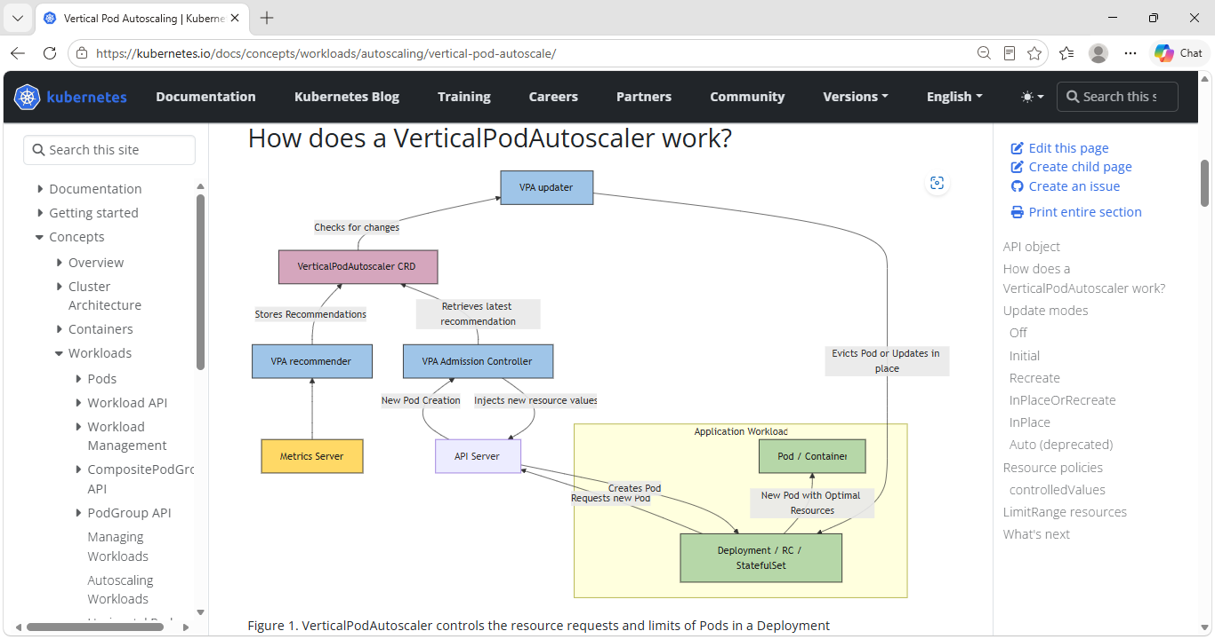Update modes
A VerticalPodAutoscaler supports different update modes that control how and when resource recommendations are applied to your Pods. You configure the update mode using the updateMode field in the VPA spec under updatePolicy:
---
apiVersion: autoscaling.k8s.io/v1
kind: VerticalPodAutoscaler
metadata:
name: my-app-vpa
spec:
targetRef:
apiVersion: "apps/v1"
kind: Deployment
name: my-app
updatePolicy:
updateMode: "Recreate" # Off, Initial, Recreate, InPlaceOrRecreate, InPlace

Off
In the Off update mode, the VPA recommender still analyzes resource usage and generates recommendations, but these recommendations are not automatically applied to Pods. The recommendations are only stored in the VPA object's .status field.
You can use a tool such as kubectl to view the .status and the recommendations in it.

Initial
In Initial mode, VPA only sets resource requests when Pods are first created. It does not update resources for already running Pods, even if recommendations change over time. The recommendations apply only during Pod creation.

Recreate
In Recreate mode, VPA actively manages Pod resources by evicting Pods when their current resource requests differ significantly from recommendations. When a Pod is evicted, the workload controller (managing a Deployment, StatefulSet, etc) creates a replacement Pod, and the VPA admission controller applies the updated resource requests to the new Pod.

InPlaceOrRecreate
In InPlaceOrRecreate mode, VPA attempts to update Pod resource requests and limits without restarting the Pod when possible. However, if in-place updates cannot be performed for a particular resource change, VPA falls back to evicting the Pod (similar to Recreate mode) and allowing the workload controller to create a replacement Pod with updated resources.
In this mode, the updater applies recommendations in-place using the Resize Container Resources In-Place feature.

InPlace
This mode is available as an alpha feature in VPA 1.7.0 and requires Kubernetes 1.33 or later with the InPlacePodVerticalScaling cluster feature gate enabled, and the InPlace feature gate enabled on the VPA updater and admission controller. It uses the in-place Pod resize feature to apply updates without disrupting the Pod.
In InPlace mode, VPA attempts to update Pod resource requests and limits without restarting or evicting the Pod. Unlike InPlaceOrRecreate, this mode never falls back to eviction. If an in-place update cannot be applied (for example, because the node does not have enough capacity), VPA defers the update and retries it in a subsequent reconciliation loop.
To use InPlace mode, enable the InPlace feature gate on both the VPA updater and admission controller:
--feature-gates=InPlace=true
Then set updateMode to "InPlace" in your VPA spec:
apiVersion: autoscaling.k8s.io/v1
kind: VerticalPodAutoscaler
metadata:
name: my-app-vpa
spec:
targetRef:
apiVersion: "apps/v1"
kind: Deployment
name: my-app
updatePolicy:
updateMode: "InPlace"

Resource policies
Resource policies allow you to fine-tune how the VerticalPodAutoscaler generates recommendations and applies updates. You can set boundaries for resource recommendations, specify which resources to manage, and configure different policies for individual containers within a Pod.
apiVersion: autoscaling.k8s.io/v1
kind: VerticalPodAutoscaler
metadata:
name: my-app-vpa
spec:
targetRef:
apiVersion: "apps/v1"
kind: Deployment
name: my-app
updatePolicy:
updateMode: "Recreate"
resourcePolicy:
containerPolicies:
- containerName: "application"
minAllowed:
cpu: 100m
memory: 128Mi
maxAllowed:
cpu: 2
memory: 2Gi
controlledResources:
- cpu
- memory
controlledValues: RequestsAndLimits

apiVersion: apps/v1
kind: Deployment
metadata:
name: my-app
labels:
app: my-app
spec:
replicas: 2
selector:
matchLabels:
app: my-app
template:
metadata:
labels:
app: my-app
spec:
containers:
- name: application
image: nginx:latest # Replace with your actual application image
ports:
- containerPort: 80
resources:
requests:
cpu: 200m
memory: 256Mi
limits:
cpu: 400m
memory: 512Mi

